Would you like to have a job with summers off?

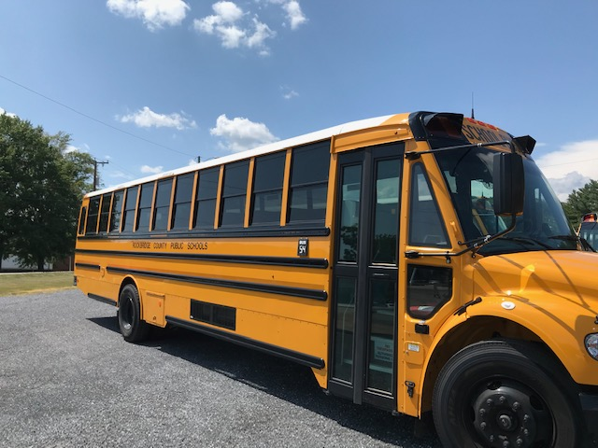

Come Join our Fleet!

Requirements: 48 hours paid training (Conducted by RCPS)

24 hours’ classroom training

24 hours’ road training (12 w/out students, 12 w/students)

Obtain Commercial Driver’s License w/ School Bus & Air Brake endorsement

Yearly Physical (paid by RCPS)

Criminal Record Check

Random Drug/Alcohol Testing

12 hours annual In-Service Training

Annual Evaluations

Like working closely with children

**Pay: Based on length of route for 180 school days & 2 days’ in-service**

**(avg. route is 3 hours per day at $29.16/hour)**

**Substituting- $60.00/day or $30.00/half day**

**Eligible for Field Trips, Athletic Trips, Activity Runs @ $13.39/hour**